***Documentation on cyber security***



Report on project

By mohamad iliyas.i

REG no:210181601025

SBID:SB20230645082

B.S.Abdur Rahman crescent institute of science and technology

Day 1

BUG BOUNTY Program

Task -1

Step -1

Hackerone.com

Step -2

Domain name exploring

Step -3

# I choose A.S. Watson Group

Step -4

Osint framework in another tab

Step -5

Domain name whois records -whois

Step -6

Whois redirects to new tab

Step -7

Paste the domain name

Step -8

I got some information of that site

Domain name: A.S. Watson Group([https://www.aswatson.com](https://www.aswatson.com/))

Status: aswatson.com is **unavailable**

### Other matching domains that are available

aswatson.io

aswatson.online

aswatson.store

aswatson.space

aswatson.co

aswatson.xyz

aswatson.pw

aswatson.co.in

aswatson.in.net

buyaswatson.com

aswatson.site

asdearwatson.com

aswatson.website

buyaswatson.online

allaswatson.com

aswatsongroup.online

buyaswatsongroup.com

# aswatson.com

Updated 1 day ago

**Domain Information**

Domain:

aswatson.com

Registrar:

CSC Corporate Domains, Inc.

Registered On:

2002-03-23

Expires On:

2024-03-23

Updated On:

2022-11-15

Status:

clientTransferProhibited

Name Servers:

a1-124.akam.net  
a12-67.akam.net  
a13-67.akam.net  
a2-65.akam.net  
a20-64.akam.net  
a5-67.akam.net

**Registrant Contact**

Name:

Domain Administrator

Organization:

A.S. Watson TM Limited

Street:

Vistra Corporate Services Centre, Wickhams Cay II, Road Town

City:

Tortola

Postal Code:

VG1110

Country:

VG

Phone:

+852.21281188

Fax:

+852.21281705

Email:

email@ckh.com.hk

**Administrative Contact**

Name:

Domain Administrator

Organization:

A.S. Watson TM Limited

Street:

Vistra Corporate Services Centre, Wickhams Cay II, Road Town

City:

Tortola

Postal Code:

VG1110

Country:

VG

Phone:

+852.21281188

Fax:

+852.21281705

Email:

email@ckh.com.hk

**Technical Contact**

Name:

Domain Administrator

Organization:

Watson Enterprises Limited

Street:

P.O. Box 146, Trident Chambers, Wickhams Cay

City:

Road Town

State:

Tortola

Postal Code:

VG1110

Country:

VG

Phone:

+852.21281188

Fax:

+852.21281705

Email:

email@ckh.com.hk

**Raw Whois Data**

Domain Name: aswatson.com

Registry Domain ID: 84780480_DOMAIN_COM-VRSN

Registrar WHOIS Server: whois.corporatedomains.com

Registrar URL: www.cscprotectsbrands.com

Updated Date: 2022-11-14T20:25:39Z

Creation Date: 2002-03-22T23:06:24Z

Registrar Registration Expiration Date: 2024-03-23T03:06:24Z

Registrar: CSC CORPORATE DOMAINS, INC.

Sponsoring Registrar IANA ID: 299

Registrar Abuse Contact Email: email@cscglobal.com

Registrar Abuse Contact Phone: +1.8887802723

Domain Status: clientTransferProhibited http://www.icann.org/epp#clientTransferProhibited

Registry Registrant ID:

Registrant Name: Domain Administrator

Registrant Organization: A.S. Watson TM Limited

Registrant Street: Vistra Corporate Services Centre, Wickhams Cay II, Road Town

Registrant City: Tortola

Registrant State/Province:

Registrant Postal Code: VG1110

Registrant Country: VG

Registrant Phone: +852.21281188

Registrant Phone Ext:

Registrant Fax: +852.21281705

Registrant Fax Ext:

Registrant Email: email@ckh.com.hk

Registry Admin ID:

Admin Name: Domain Administrator

Admin Organization: A.S. Watson TM Limited

Admin Street: Vistra Corporate Services Centre, Wickhams Cay II, Road Town

Admin City: Tortola

Admin State/Province:

Admin Postal Code: VG1110

Admin Country: VG

Admin Phone: +852.21281188

Admin Phone Ext:

Admin Fax: +852.21281705

Admin Fax Ext:

Admin Email: email@ckh.com.hk

Registry Tech ID:

Tech Name: Domain Administrator

Tech Organization: Watson Enterprises Limited

Tech Street: P.O. Box 146, Trident Chambers, Wickhams Cay

Tech City: Road Town

Tech State/Province: Tortola

Tech Postal Code: VG1110

Tech Country: VG

Tech Phone: +852.21281188

Tech Phone Ext:

Tech Fax: +852.21281705

Tech Fax Ext:

Tech Email: email@ckh.com.hk

Name Server: a2-65.akam.net

Name Server: a20-64.akam.net

Name Server: a5-67.akam.net

Name Server: a1-124.akam.net

Name Server: a12-67.akam.net

Name Server: a13-67.akam.net

DNSSEC: unsigned

URL of the ICANN WHOIS Data Problem Reporting System: http://wdprs.internic.net/

>>> Last update of WHOIS database: 2022-11-14T20:25:39Z <<<

For more information on Whois status codes, please visit https://icann.org/epp

Corporation Service Company(c) (CSC) The Trusted Partner of More than 50% of the 100 Best Global Brands.

Contact us to learn more about our enterprise solutions for Global Domain Name Registration and Management, Trademark Research and Watching, Brand, Logo and Auction Monitoring, as well SSL Certificate Services and DNS Hosting.

NOTICE: You are not authorized to access or query our WHOIS database through the use of high-volume, automated, electronic processes or for the purpose or purposes of using the data in any manner that violates these terms of use. The Data in the CSC WHOIS database is provided by CSC for information purposes only, and to assist persons in obtaining information about or related to a domain name registration record. CSC does not guarantee its accuracy. By submitting a WHOIS query, you agree to abide by the following terms of use: you agree that you may use this Data only for lawful purposes and that under no circumstances will you use this Data to: (1) allow, enable, or otherwise support the transmission of mass unsolicited, commercial advertising or solicitations via direct mail, e-mail, telephone, or facsimile; or (2) enable high volume, automated, electronic processes that apply to CSC (or its computer systems). CSC reserves the right to terminate your access to the WHOIS database in its sole discretion for any violations by you of these terms of use. CSC reserves the right to modify these terms at any time.

Register your domain name at <http://www.cscglobal.com>

I have done the vulnerability test by using (owasp)zap tool

By demonstrating the manual and automated attack

I have given the drive video link here

<https://drive.google.com/file/d/1RhCx_Aj2lVxg0JwguJRgYQVYzBEc7VT0/view?usp=drive_link>

and also tested with PwnXSS

and XSStrike

the results were

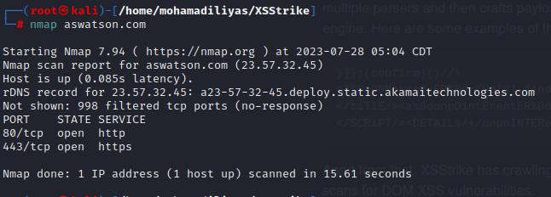

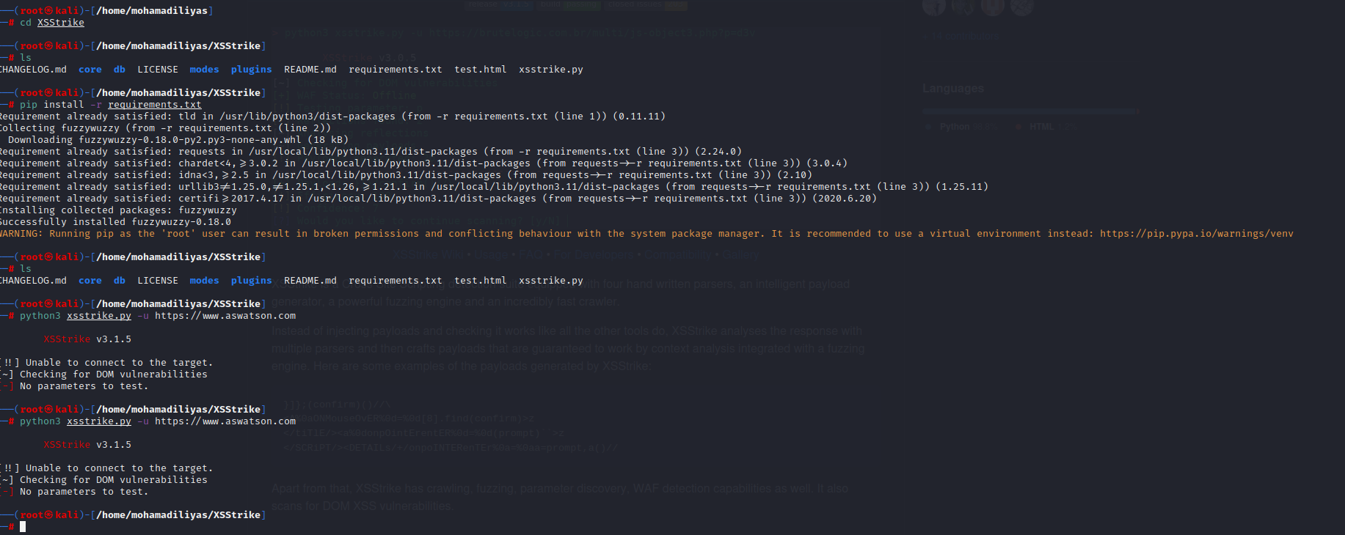Thank you

And this was my bug bounty project